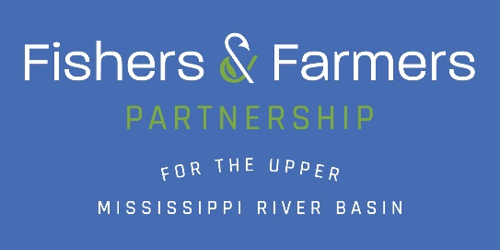
Fishers & Farmers Partnership’s Proposal for Funding
National Fish Habitat Partnership & U.S. Fish & Wildlife Service

What type of action would you like the FHP to consider (check the one that applies)

- Project Funding
- Science, and Planning Support
- Communications
- Project Endorsement

FWS Funding Request:

Project Total (including all match):

Match: In-Kind Match: Cash
1:1 non-Federal required, 3:1 improves chances of funding
Funding must not be matched to another federal grant
CONTACT INFORMATION
Project Officer(s) Project Co-Officer(s)
Name: |  | Name:
Affiliation |  | Affiliation
Mailing Address: |  | Mailing Address:
Email Address: |  | Email Address:
Phone Number: |  | Phone Number:

TITLE OF THE PROJECT (99 characters max):

DESCRIPTION OF ENTITY UNDERTAKING PROJECT
(circle)

Tribal, Federal, State, County, Non-Government Organization, Business, Other
PROJECT TYPE (Construction/Non Construction) (circle)
Fish Passage – culvert/lowhead dam Education/Outreach
Habitat Assessment Monitoring Recreational
Bank Stabilization In-Stream Habitat
Coordination/Technical Assistance Engineering/Project Design
Best Management Practices
Farmer Led Council/Committee

SPECIFIC WATER BODY NAME AND LOCATION
Watershed/Stream Name | County | State | Latitude | Longitude | Section/Township/  Range
Upper Mississippi River  Basin |  | WI, MN,  IA,IL, MO
STATE AND/OR FEDERAL AGENCY RESPONSIBLE FOR FISH MANAGEMENT:

Contact Name:
Address:

Telephone:
Email:

SECTION 1.

PROJECT NARRATIVE

- Statement of Need/Purpose: Explain why the project is necessary (significance/value) and how it fulfills the purpose of the Fishers & Farmers Partnership and the National Fish Habitat Partnership Program. Identify the conservation issue, problem, or opportunity to be addressed. Provide evidence such as results from surveys, research or other data to demonstrate the real (not perceived) need. Summarize previous or on-going efforts relevant to project. Identify the negative result of taking no action.

- Goals/Objectives: State the desired outcome of the proposed project in specific and quantified terms. Objectives are the specific outcomes to be accomplished in order to reach the stated goal. Objectives are meant to be realistic targets or benchmarks that will resolve the project need. Objectives are written in an active tense and use action verbs such as construct, survey, train, research, establish, repair, conduct, provide, acquire.

- Project Activities, Methods, and Timetable: List the proposed project activities and describe how they relate to the stated objectives. Activities are the specific actions to be undertaken to fulfill the project objectives and reach the project goal(s). For projects being conducted within the United States, the narrative must provide enough detail so that reviewers are able to determine project compliance with state and federal laws. Provide a timetable indicating month/year when activities or project milestones are to be accomplished. Include any resulting tables, spreadsheets or flow charts within the body of the project narrative (do not include as separate attachments). For Cooperative Agreements, specify tasks/ deliverables where the U.S. Fish and Wildlife Service will be substantially involved in assisting with carrying out the objectives of the project.

- Stakeholder Coordination/Involvement: As applicable, describe how you/your organization has coordinated with and involved other relevant organizations or individuals in planning the project, and detail if/how they will be involved in conducting project activities, disseminating project results and/or incorporating your results/products into their activities.

PERFORMANCE
Amount and type of habitat affected (Fill in boxes)
In-stream miles restored/enhanced
Riparian miles restored/enhanced
Riparian acres restored/enhanced
(length of stream x width of area)
Wetland acres restored/enhanced
Upland acres restored/enhanced
Other habitat type restored/enhanced (specify)
Number of management populations assessed
Total number of miles in-stream/shoreline habitat assessed
Number of acres of upland habitat assessed
Number of acres of wetland habitat assessed
Total number of fish passage barriers removed or bypassed
Number of miles re-opened to fish passage
Number of acres re-opened to fish passage

Conservation Actions Taken (Check all that apply)
Install upland Best Management Practices
Stream protection/ Protect healthy habitat
Native prairie/Grassland restoration
Riparian corridor protection
Streambank stabilization
Restore native riparian vegetation
Reduce nutrient loading
Reduce sediment loading
Restore riparian habitat/Buffers
Improve physical fish habitat (woody habitat, lunker
structures, woody debris, etc.)
Restore natural stream channel form
Reconnect aquatic habitat
Control/eradicate invasive species
Restore natural stream flow/Hydrological processes
Remove fish barrier
Improve natural variability in river and stream flows
Improve floodplain habitat
Restore water temperatures
Improve sediment transport
Restore wetlands
Watershed protection

Support National Fish Habitat Partnership’s Goals
(Check all that apply)
- Protect & maintain intact and healthy aquatic systems
- Prevent further degradation of fish habitats that have been adversely affected
- Reverse declines in the quality & quantity of aquatic habitats to improve the overall
health of fish & other aquatic organisms
- Increase the quality & quantity of fish habitat that support a broad natural diversity of
Fish/aquatic species.

Support Fishers & Farmers Partnership’s Goals and Strategic Plan
(Check all that apply)
1. Engage Farmers & Ranchers
- Build awareness of Partnership
- Identify farmer/landowner needs/provide T.A.
- Increase landowner engagement/farmer-led committees that drive conservation
- Promote best management practices across the landscape with the help of farmers
2. Support Fish Habitat Conservation Projects
- Increase native fish/mussel populations
- Work with partners, to strategically place conservation on the ground
- Improve floodplain habitat, enhance flow regimes
- Reduce sedimentation, phosphorus and nitrogen runoff to stream habitats
3. Long-Term Basin Scale Strategies
- Gain knowledge of basin’s aquatic communities
- Gain knowledge of basin’s agricultural dynamics
- Monitor effectiveness of conservation projects, share our stories through outreach
4. Acquire Resources for Long-Term Action
- Form new partnerships “outside the box”
- Work with farmers/landowners to protect and maintain healthy aquatic systems or
prevent further degradation
- Have you/your organization attended a prior Watershed Leaders Circle:  Network Workshop | Y or N

PRIMARY NATIVE SPECIES:

SECONDARY SPECIES:

OTHER SPECIES/COMMUNITIES:

NUISANCE SPECIES MANAGED:

PROPOSED OUTREACH
- Describe any planned outreach or educational component(s) and partners(s) involved. (Required)
What methods will you use to promote the project if it is funded?

How will you bring more attention to fish and fish habitat than has been done in the past?

- Are there any unique aspects about this particular project?

CONGRESSIONAL DISTRICT(S): (State/Number)
PUBLIC INTEREST

Describe the public interest in this resource. Why is this a good place to invest conservation dollars?

  - Will this project enhance recreational fishing? Yes No N/A (circle one)

Will public fishing access be available? Yes No N/A (circle one)

  - Is there a stream/river designation or fishery/management designation identified by a federal or state natural resource agency?

  - Land ownership at project location (check all that apply for project area – Note: more attention will be given to privately owned – farmed land)

Federal
State

County
City

Private

Non-governmental Organization Tribal Other_____

CONSERVATION EASEMENTS (Funding will be allowed with state approval)
Is a conservation easement in place or in the process of purchase? Yes

NO (check one)

If you answered yes above, is it a new or existing easement? New (check one)

Is the easement perpetual? Yes

No
(check one)

If no, what is the length of easement (years)

FUNDING INFORMATION Estimate FWS funding for up to five years: Only one fiscal year can be funded with this request, but you have two years to spend funding.
Fund | Year |  |  |  |  | Total
 | 1 | 2 | 3 | 4 | 5
NFHP/FFP

BUDGET JUSTIFICATION & NARRATIVE: Provide sufficient information to show project is cost effective. Describe any item that requires FWS approval. Make sure budget is identical to SF424 & SF424A/C.
A) PERSONNEL/ADMINISTRATIVE (SF-424A Object Class Category 6a.)
The cost of salaries & wages, not including fringe benefits, paid to Recipient employees working directly on this agreement. Indicate Key Personnel with an asterisk (*). Provide more detail in the Narrative Box if needed.
Name & Title or Position Title | Salary or Wage | Months or Hours | Matching Funds  (if applicable) | FWS  Funds
Example: James Smith, Executive Director | $50 per hour | 400 hours | $5,000.00 | $15,000.00

A) TOTAL PERSONNEL COSTS:
(SF-424A Object Class Category 6a. Personnel)
Narrative:
We are requesting $39,999.90 to pay a graduate research assistant to assist lead field research, including sampling, tagging, tracking, and downloading acoustic receivers and also to manage and analyze data, write a report (thesis), and present findings. Undergraduate students will assist with field research over the course of the project ($15,500). Dr. xxxxxx mentor the graduate student, assist with field sampling and data analysis, and complete the final report (total of two months summer salary requested from FWS, $10,888, with $3,000 (0.55 month of summer salary)
provided as match from the College of xxxxx).

B) FRINGE BENEFITS (SF-424A Object Class Category 6b.)
The cost of fringe benefits, such as health insurance, vacation, FICA, etc., paid to Recipient employees working on this agreement. List employees or positions below, and their fringe benefit rates as percentages of their salaries. List what are included as fringe benefits in the Narrative Box.
Name & Title/Position | Salary/Wage Base (FWS Amounts budgeted in Section  A above) | Fringe Benefit Rate (%) | Matching Funds  (if applicable) | FWS  Funds
Example: James Smith, Executive Director | $20,000.00 | 30% | $0.00 | $6,000.00
B) TOTAL FRINGE BENEFIT COSTS:
(SF-424A Object Class Category 6b. Fringe Benefits)
Narrative:
We request funds for fringe benefits for a graduate research assistant ($22,559.94), undergraduate technicians ($1,029.50), and a requested 2 months of summer salary and 0.55 month of summer salary match for Dr. xxxxx. The University of xxxxxx determines fringe rates on an annual basis, therefore the rate shown for graduate research assistant and undergraduate student technicians is assuming increases consistent with past increases.
The rate for Dr. xxxxxx is 53.9% for match and estimated as 63.9% in 2017-2018 and 68.9% in 2018-2019.

C) TRAVEL (SF-424A Object Class Category 6c.)
LODGING & PER DIEM - The cost of lodging & meals while travelling for agreement activities. Give details and purpose of the travel in the Narrative Box. Current Federal rates may be found online at: http://www.gsa.gov/portal/category/21287.
Proposed Travel Lodging & Per Diem |  | No. of People |  | No. of Days |  | Cost Per Person Per  Day |  |  | Matching Funds  (if applicable) | FWS  Funds
To: From:
MILEAGE REIMBURSEMENT - The cost of reimbursement for estimated mileage traveled for agreement activities. Give details and the purpose of the travel in the Narrative Box. Current Federal mileage reimbursement rates may be found online at: www.GSA.gov.
Proposed Travel Mileage Reimbursement |  |  | No. of Miles |  | No. of Trips |  | Cost Per Mile | Matching Funds  (if applicable) |  | FWS  Funds
To: From:
OTHER TRAVEL COSTS - The costs of airfare, bus fare, car rental, etc., required for agreement activities. Explain the details and the purpose of the costs in the Narrative Box.

 | Proposed Other Travel Reimbursement |  | Type | Cost | No. | Matching Funds  (if applicable) | FWS  Funds
 | To: From:
C) TOTAL TRAVEL COSTS:
(SF-424A Object Class Category 6c. Travel)
Narrative:
We are asking for a total of $15,000 for traveling expenses related to field research and $2,000.00 for presenting our findings. We have estimated $1,428.00 for two people to make up to 14 day trips to xxxx where the fish elevator is located. We also anticipated three partial days (not full per diem) for field research and meetings, accounting for $66.90. In addition to day trips, extended periods at the fish elevator will be necessary and we have estimated $10,505 for 2 people sharing lodging for up to 55 days across the study. Travel will be both to the fish elevator (262 miles round trip from xxxx) and to other xxxx River locations to download acoustic receivers and track fish (approximately 61 miles round trip from the fish elevator). We will be using a state
owned 4x4 truck to tow boats

D) SUPPLIES/EQUIPMENT (SF-424A Object Class Category 6e. Supplies)
The cost of materials and supplies, equipment used directly on this project, such as safety glasses, work gloves, office supplies, etc. Explain the details and purpose in the Narrative box below.
Item | Quantity | Cost per Unit | Matching Funds  (if applicable) | FWS  Funds
D) SUPPLIES COST TOTAL:
(SF-424A Object Class Category 6e. Supplies)
Narrative:

E) CONTRACTUAL/ CONSTRUCTION (SF-424A Object Class Category 6f. Contractual)
The cost of construction, contracted services and/or sub-recipient agreements. Provide names and explain the details and purpose of the costs in the Narrative box below.
Contractor Name, Type, etc. | Cost | Matching Funds  (if applicable) | FWS  Funds
Example: Ace Backhoe Service / Excavator | $2,500.0 0 | $0.00 | $2,500.00
E) CONSTRUCTION/CONTRACTUAL COST TOTAL:
(SF-424A Object Class Category 6f. Contractual)
Narrative:

F) OTHER/MISCELLANEOUS (SF-424A Object Class Category 6h. Other)
Costs that don't fit any other Object Class Category, such as duplicating and printing, postage and freight, rented equipment, etc. Explain the details and purpose in the Narrative box below.
Item | Cost | Matching Funds  (if applicable) | FWS  Funds
F) OTHER COSTS TOTAL:
(SF-424A Object Class Category 6h. Other)
Narrative:

G) TOTAL DIRECT CHARGES (SF-424A Object Class Category 6i. Sum of 6a.-6h.)
The total of all direct costs applicable to this project.
Direct Costs | Matching Funds  (if applicable) | FWS  Funds
G) TOTAL DIRECT COSTS:
(SF-424A Object Class Category 6i. Total, Sum of 6a.-6h.)

H) INDIRECT COSTS (SF-424A Object Class Category 6j. Indirect Charges)
Base amount for this Grant:
(Total Direct Costs, Total Labor Costs, MTDC, etc.)
Rate to be used on this Grant (%):
Indirect Costs |  | Matching Funds  (if applicable) | FWS  Funds
H) TOTAL INDIRECT COSTS:
(SF-424A Object Class Category 6j. Indirect Charges)
Narrative:

I) TOTALS (SF-424A Object Class Category 6k. TOTALS)
The sum total of Direct and Indirect Costs (Sum of 6i. & 6j.) applicable to this agreement.
Total Project Costs | Matching Funds  (if applicable) | FWS  Funds
I) TOTAL COSTS:
(SF-424A Object Class Category 6k. TOTALS)

By signing below, I certify that to the best of my knowledge the costs detailed above are correct and complete and for the purposes set forth in the application for Federal Assistance.
Signature
Printed Name & Title of Person Completing Budget

Contributing Partners Please list specific partner names (not FFP or your organization) and proposed contributions, including in-kind service and/or cash value (example: 300 volunteer hours of shoreline restoration-In-kind value $5,000). Text will wrap to a new line if necessary.
Contributing Partner | Partner category  (Tribal/Fed/State/CountyNGO/Business) | Project Need Addressed (Design, Equipment,  Materials) | Cash | In-kind | Total Amount
Total
Note: Projects with a higher match have a better chance of funding.

FEDERAL FUNDING

    - Have you received Federal funding in the past? Yes No (Circle)

    - Under what Federal Funding Opportunity? (provide Grants.gov Catalog of Federal Domestic Assistance Number CFDA)

Was your organization required to complete an A-133 Single Audit Report last year? Yes No (Circle)

    - Is your DUNS/SAM/ASAP profile currently active? Yes No Not Sure (Circle)

Has National Environmental Policy Act (NEPA) been completed on this project prior to making a funding request?
Yes No (Circle) (Please attach NEPA Documentation if applicable)

Has the (Endangered/Threatened Species Review) Section 7 with the USFWS and/or State Natural Resource Agency been completed? Yes No (Circle)
(Please attach documentation if applicable)

    - Has the historic/cultural review with State Historic Preservation Office (SHPO) been completed? Yes No (Circle) (Please attach documentation if applicable)

PROJECT COMPLETION
What is your approximate start/end date for this project /
(Projects must be completed in 2 years)

Timetable or Milestones/Accomplishments:

(Indicate month/year)

SECTION 2. Additional Project Information- This section is your chance to provide more details about your project.

WATERSHED LEVEL PLANNING
Please provide any background information necessary to adequately address the below questions. Enter N/A for non-applicable

Is the proposed project part of a larger restoration effort on the stream or in the watershed? If So, what are the general stream or watershed goals or please provide the citation and/or web link to the stream or watershed strategic or management plan(s).

- What is the current land use in the project area and watershed? (Circle all that apply)

Cropland in current production Cropland in recent production (<5 yrs) Fallow land, cropland (>5 yrs ago) Grazed/pasture
Orchard, grove, vineyard Other Ag land Grassland/Prairie Wetland

Riparian corridor Forest
Park – State, County Urban Resort/Tourism

- Is the project in an area of special conservation designation? (Check all that apply)

_ State Conservation Opportunity Area
_ Ten Waters to Watch

_ Ramsar (Convention on Wetlands of International Importance)
_ Joint Venture Focal Area

_ National Blueway
_ Class I Trout Stream

_ Class II Trout Stream
_ Class III Trout Stream

_ Protected stream/segment

_ 303d listed

_ Biologically significant
_ Designated threatened and endangered critical habitat (federal and state)

_ Other

- What are the proposed riparian land protection/restoration efforts in and adjacent to the project area that will help ensure long term benefits?

What are the current/future plans for upland conservation/Best Management Practices in the watershed?

- How does the project address climate change adaptation?

Describe why you feel you and your organization are qualified to successfully complete all aspects of this project.

PROJECT MONITORING AND EVALUATION **Fishers & Farmers requires a monitoring plan and annual reports on performance/monitoring.

Detail the monitoring and evaluation plan for the project. Building on the stated project objectives, which must be specific and measurable, identify what you will measure (i.e., quantitative/quantifiable indicators) and how you will measure (e.g., methods, sample size, survey tools). Reference the stated project timetable (i.e., process indicators) and budget information (i.e., input indicators). Identify the products/services to be delivered and how/to whom they will be delivered (i.e., output indicators). Detail the expected direct effect(s) of the project on beneficiaries (i.e., outcome indicators). Include any available questionnaires, surveys, curricula, exams/tests or other assessment tools to be used for project evaluation. Describe the resources and organizational structure available for gathering, analyzing and reporting monitoring and evaluation data. If applicable, describe how project participants and beneficiaries will participate in monitoring and evaluation activities. Describe how findings will be fed back into decision-making and project activities throughout the project period.

MAP OF PROJECT AREA
Please replace the example map with a map of the proposed project area showing the scope and location of project.
  - Color or black and white
  - Showing scope and location of project

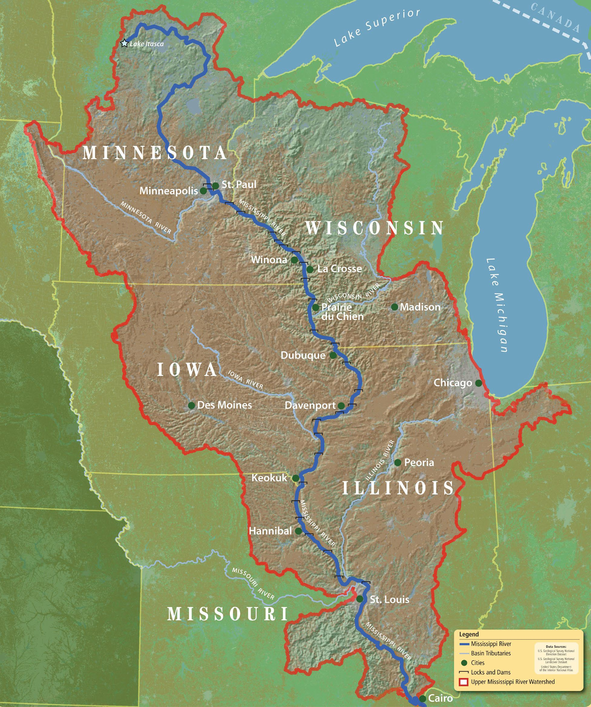
PHOTOGRAPH(S) OF PROJECT AREA (Required)
Please include up to two photographs of proposed project area. Each photo should be in JPG, TIFF, GIF, WMF or bitmap format and accompanied by:
    - A short, descriptive caption
    - Credit: Photographer’s name/organization

DOCUMENTS Please attach appropriate planning documents, permits, work plans, construction designs, maps etc. in PDF format. Notice –construction designs must be turned in if this is a construction/ground- moving project.

